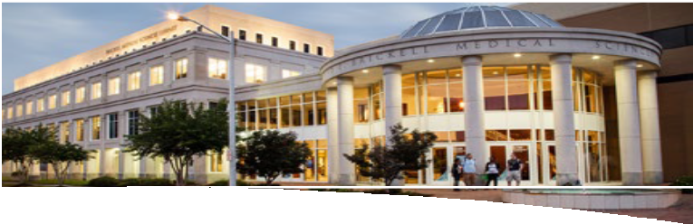

Eastern Virginia Medical School Otolaryngology is pleased to announce the:
EVMS Otolaryngology Away Rotation Grant
Norfolk, VA
$1,500 stipend
to support 4th year visiting students seeking one month “away rotation” (sub/acting-internship) in Otolaryngology 7/2024, 8/2024, or 9/2024
Offered by:
EVMS Diversity and Inclusion Subcommittee and EVMS GME EVMS Otolaryngology - Head and Neck Surgery
Eligibility: The student must be in good academic standing and enrolled in their fourth or final year at an accredited MD or DO degree program during their elective rotation at EVMS. The need for true community engagement is unlikely to occur without a workforce that is diverse in many ways. This grant is for individuals who are underrepresented in medicine, socially, economically, or educationally disadvantaged, and others whose backgrounds and experiences would diversify their clinical fields.
Details: This rotation offers an orientation to otolaryngology for the future surgeon. An emphasis will be placed on medical and surgical aspects of diseases of the head and neck with the development of specific surgical skills related to these diseases. The course will be divided between operating room experiences and office otolaryngology.
Supervision / mentorship will be weekly with a URM faculty member from the Department of Otolaryngology. They will also receive mentorship from the EVMS Office of Diversity and Inclusion. At the end of the rotation, the student will have a formal interview with the Program Director, Vice- Chairman, and Department Chair.
To Apply:
Contact Erin Mordecai, Residency Program Specialist II
email: mordecel@evms.edu, phone: 757.388.6229
Please submit the following (1-3 below) to Erin Mordecai by April 16th, 2024. Also, apply for away rotation via VSAS. Grant awardees will be notified by April 30th, 2024.
Application requirements include:
- An essay describing how you believe that your background and experience would contribute to diversity, broadly defined above (less than 750 words)
- CV
- One letter of recommendation from dean or faculty member.

Two grants will be awarded.

