
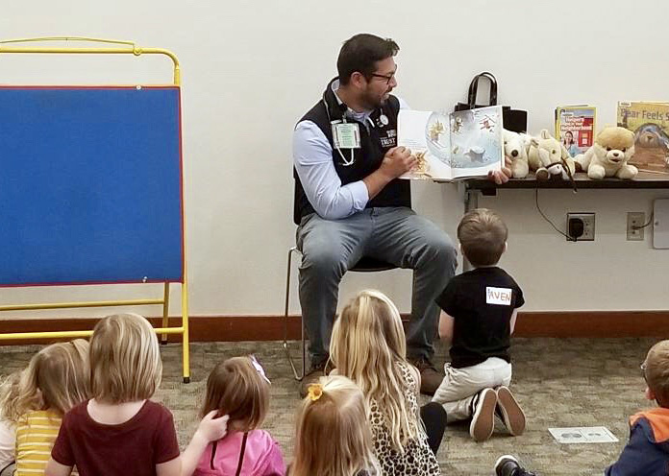
CONNECTING WITH COMMUNITY THROUGH UW’S TRUST PROGRAM
By Carlos I. Enciso Lopez,
UW School of Medicine, Seattle, 3rd Year Medical Student, TRUST Scholar

Photo of Carlos connecting with preschoolers in Lynden Public Library as a Storytime reader for his service project

The University of Washington School of Medicine is committed to helping solve physician workforce issues in underserved areas of the five-state region served by the medical school: Washington, Wyoming, Alaska, Montana and Idaho—known as WWAMI. To that end, in the late 1970s the UW started the TRUST program—Targeted Rural and Underserved Track—to connect medical students interested in caring for the underserved within rural communities and small cities in the WWAMI region.

TRUST students receive a focused experience—an opportunity to learn what it’s like caring for patients in one small city or rural community throughout their four years of medical school. This

program incorporates service projects as well as medical training under the guidance of local physicians.

In Lynden, Washington, a town of just over 14,000, third-year TRUST student Carlos I. Enciso Lopez is training in the Lynden Family Medicine Clinic. Lynden, located just south of the Canadian border, is Carlos’ TRUST community.

There are advantages to training in a small community, including less competition for training time during exciting procedures such as labor and delivery, and with a smaller patient pool, you can establish relationships with some patients that you see multiple times.

“Even though we don’t have an OB-GYN rotation in Lynden, I am able to accompany doctors to deliveries,” Carlos said. “Probably the most surprising thing I’ve learned so far in medical school is simply how much I enjoy connecting with people. I wasn’t expecting this. I’m only in my third year and I’ve already started seeing patients for follow-up visits. It’s harder to get this experience in a larger city.”

For a service project Carlos recently spent time connecting with preschoolers in the Lynden Public Library as a Storytime reader.

“The library regularly invites people from the clinic to participate in Storytime,” said Carlos. “I read the kids a story—they were all between three and five years old—but they had more fun with the props I brought—a skeleton, a stethoscope and an otoscope. We like to bring safe medical tools for the kids to touch and play with because it teaches them not to be afraid of going to the doctor. We all had a blast!”

TRUST students also participate in two additional rural programs, extending the total time in their “continuity community” to up to 30 weeks: one to two weeks before the start of their first year, four weeks between the first and second years for their RUOP—Rural Underserved Opportunities Program—and 22-24 weeks of clinical education during the third year of medical school in a program called WRITE: WWAMI Rural Integrated Training Experience.

The goal of TRUST is that after medical school and completing residency training, the students will return to an underserved community to practice. Carlos is originally from Wenatchee in eastern Washington and plans to return to the Wenatchee Valley after medical school.

“There is definitely a lack of primary care doctors across the state, especially doctors of color and bilingual doctors,” says Carlos. “Although I was raised in eastern Washington from kindergarten through high school, I am a first generation immigrant from Mexico, and the first person in my family to graduate from college.”

He went on to say, “There is a large community of Hispanic people living in eastern Washington, but there aren’t many Hispanic doctors, and although some of the non-Hispanic physicians have

learned conversational Spanish, it’s different when you grow up in the culture. As a Latino I can fill a gap in medicine for a lot of Hispanic patients who would really like to see someone who genuinely understands their situation or life struggles.”

And that is something he is contributing to the Lynden Family Medicine Clinic too.

“I have interpreted on multiple occasions in the clinic and my preceptor always lets me work with Spanish speaking patients. He thinks it leads to better quality of care if they are comfortable speaking with me,” he said.

Nearing his last year of medical school, Carlos reflected on how he got interested in becoming a physician. His background didn’t include doctors reading him stories, or playing with medical tools. In fact, growing up poor and as an immigrant, a career in medicine was not even a consideration.

“After college I thought about being a nurse. I worked for three years at Columbia Valley Community Health in Wenatchee and that was a real turning point for me,” he says. “I worked with really inspirational nurses, physician assistants and MDs who genuinely believed I could make it as a doctor and pushed me to pursue goals I would never have dreamed of without them. Their support made me feel like I could do this—I could pursue a career as a physician.”

