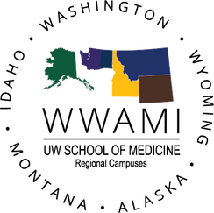

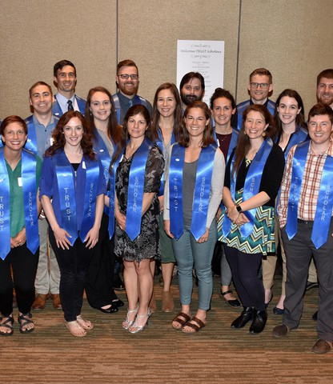
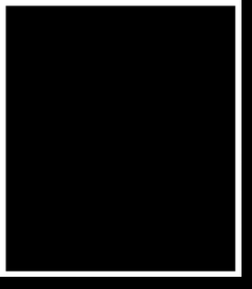
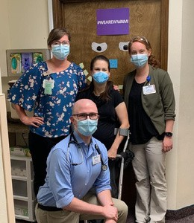
MORE INFORMATION:
206-543-4110
https://education.uwmedicine.org/somrural/
somrural@uw.edu

UNIVERSITY of WASHINGTON SCHOOL of MEDICINE

TRUST
PROGRAM 2026
Targeted Rural Underserved Student Track (TRUST) is a longitudinal curriculum that aims to provide a continuous connection between rural underserved communities, medical education, and health professionals in our region. The ultimate goal is to create a physician workforce specifically trained for the underserved areas of Washington, Wyoming, Alaska, Montana, and Idaho (WWAMI).

Welcome to your first steps into rural and underserved medicine!
TRUST offers a unique opportunity for students from any of the WWAMI states to make intimate connections with a small community early-on in their medical school studies. You will be repeatedly returning to the same community for each clinical experience and are expected to become an integral part of the health care system at your site. Additionally, this long-term clinical relationship will connect you to a strong community of faculty, providers, and peer colleagues for enhanced mentorship, skill-development, and an apprenticeship-style of medical training.

Much of what the TRUST Program delivers will enhance your UW medical school experience with a focus on rural healthcare. Read on for more about what makes the TRUST program unique within the UW School of Medicine!

THINGS TO GET EXCITED ABOUT WITH TRUST:

Now that you have passed the TRUST admissions process, you will be linked to a small-city or rural community within the WWAMI state where you will attend medical school. You can expect to return to your TRUST community at multiple points during your medical training. The following are required components of the TRUST program:

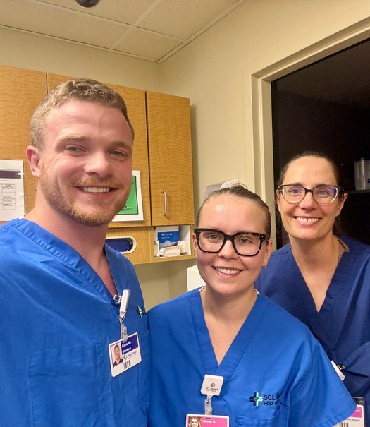
First Summer Experience (FSE)
- Students will spend several days to a couple of weeks in the TRUST continuity site getting to know the clinic, the health care team, and the community itself. As this is pre-matriculation, the focus is not clinical skill-development but rather relationship-building and getting to know your TRUST site. Usually, it occurs during May - June prior to orientation.

During the MS1 & MS2 Years (15-months)*
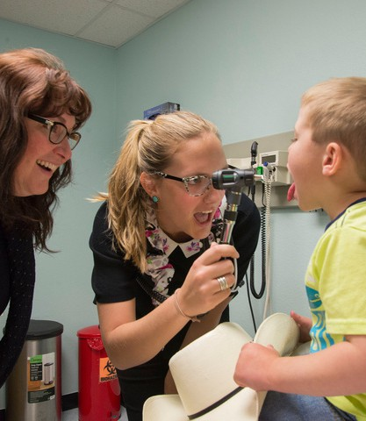
- While non-TRUST students often remain on campus or nearby during these periods, TRUST students have multiple opportunities (dependent on region) to return to their TRUST site for short periods to apply their learning directly in the field and under the guidance of their main community preceptor.

Rural Underserved Opportunities Program (RUOP)
- TRUST students are expected to return to their TRUST site for this combined 4-week clinical immersion and scholarly program in the summer between their 1st and 2nd year of medical school. RUOP satisfies the Independent Investigative Inquiry requirement for the UWSOM.

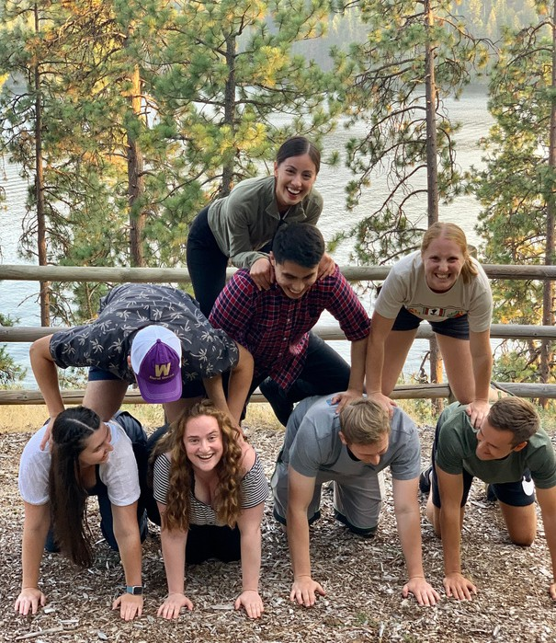
WWAMI TRUST LEADERSHIP RETREAT (Required)
- A unique opportunity to meet the rest of the WWAMI TRUST cohort, this retreat is a 4-day event, usually in late summer prior to the onset of Year 2 curriculum. Focuses on strengthening leadership and advocacy skills that rural providers often rely upon while working in smaller communities.

WWAMI Rural Integrated Training Experience (WRITE)
- A flagship program of the TRUST experience, WRITE is a 21-24 week clerkship that takes place at the TRUST continuity site. TRUST students have the benefit of leveraging existing skills and relationships at their sites to advance their clinical learning and build confidence in direct patient care.
- Due to the length of the clerkship, students will need to relocate to their TRUST site for the experience. In addition, the WRITE clerkship also has fixed 3rd year inpatient clerkships that enhance the rural learning experience. This can impact the timing of other clerkship and elective scheduling.
- Rural medicine offers distinct advantages which are balanced with the goals of UWSOM. As a regional medical school, there are clerkships that are required in larger cities and hospitals for all UW medical students. Seattle housing is not paid for TRUST students and there will be required time in Seattle.

We are excited for you to be a part of TRUST and impact rural and underserved healthcare in your state!
We encourage you to connect with your Regional TRUST Office about any questions you may have.

*Schedule for exact travel dates dependent upon curricular and regional needs which will be communicated to students as known/available

