WWAMI

TRUS T
Are you interested in rural and underserved medicine?
If the answer is YES,consider the Idaho WWAMI TRUST program!
The Targeted Rural Underserved Track (TRUST) is an award-winning longitudinal medical school experience in rural and small city underserved communities, with a goal to produce physicians committed to practicing in rural and underserved areas of Idaho and the WWAMI region.

Understanding TRUST

WHATIS TRUST?

TargetedRuralUnderserved Track
TRUST is a longitudinal
curriculum that seeks to provide a continuous connection
between underserved
communities, medical education, and health professionals in our region. The eventual goal is to create a physician workforce
specifically trained for the
underserved areas of Idaho and the WWAMI region.
https:/depts.washington.edu/ fammed/education/programs/ trust/

WHATIS RUOP?

RuralUnderservedOpportunitiesProgram
As a component of TRUST, RUOP is a 4-week community medicine immersion experience for students between their first and second years of medical school. During their 4-week rotation, students live in rural or urban underserved
communities throughout Idaho and the WWAMI region. They work side-by-side with local
physicians, providing health care to underserved populations.
RUOP provides students with an early exposure to the challenges and rewards of practicing
primary care medicine in a rural or urban
underserved setting, an opportunity to learn how community health care systems function, and promotes a positive attitude toward rural and urban underservedcommunity medicine.

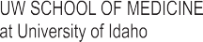
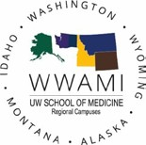
https:/depts.washington.edu/fammed/ education/programs/ruop/

WHATIS WRITE?

WWAMIRuralIntegratedTraining Experience
WRITE is a longitudinal integrated clerkship training for students during the Patient Care Phase of medical school.
WRITE was developed to help meet the need for more rural primary care physicians in Idaho and the WWAMI region. This unique program has been successful because of its integration of community involvement, continuity of experience, and proven curriculum. Emphasis is on the rural physician’s roles and responsibilities to diagnose, treat, and manage the majority of health problems on a longitudinal, continuing basis while calling upon the health care resources of the community.
https://blogs.uw.edu/write/

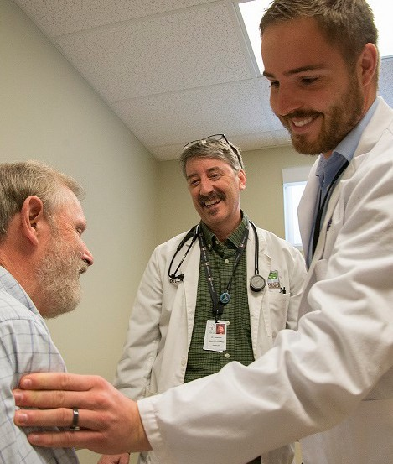

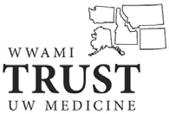
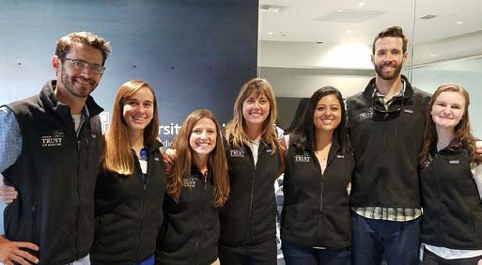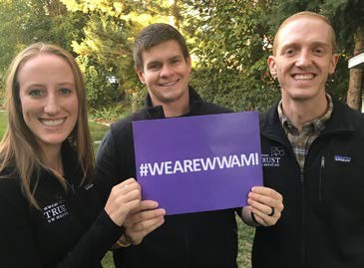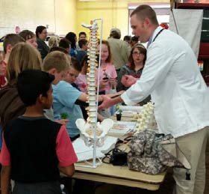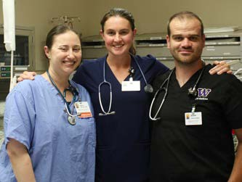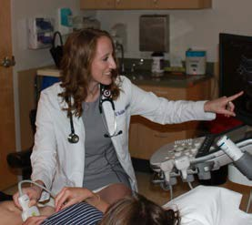TRUST
FOR MORE INFORMATION CONTACT:
MaryE.Barinaga,M.D.
barinm@uw.edu
Frank M.Batcha,Jr.,M.D. RaymeGeidl,M.D.
fbatchf@uw.edu rgeidl@uidaho.edu
OR VISIT: https://education.uwmedicine.org/somrural/programs/trust/
Curriculum and Opportunities

After a targeted TRUST admissions process, TRUST scholars are linked to small city, underserved or rural communities in Idaho for a series of educational experiences throughoutfour years of medical school.

TRUSTFirstSummerExperience (FSE)
TRUST scholars spend 1 to 2 weeks in their TRUST continuity community for a summer experience before the beginning of the Foundations Phase.
FoundationsPhase
✦ First 18 months of medical education is based at University of Idaho in Moscow, Idaho. TRUST scholars complete one or more selective courses during each term with a focus on underserved rural or
underserved small city practice, while returning to their continuity community for short periods of the Foundation Phase.
RuralUnderservedOpportunitiesProgram(RUOP)Experience
Occurs during the summer months of the Foundations Phase.
PatientCarePhase
Patient Care clinical clerkships in Seattle or throughout the WWAMI region.
WWAMIRuralIntegratedTrainingExperience(WRITE)
✦ Longitudinal, integrated clerkship training that allows
students to provide continuity care for a panel of patients within their continuity community.
Opportunities andSupport
✦ Linkage with existing UW programs such as the Rural Underserved Opportunities Program (RUOP) and the Underserved Pathway (UP), in addition to unique curricular elements, allows TRUST scholars to
immerse themselves in the care of the underserved.
✦ TRUST scholars are encouraged to attend regional and national
meetings related to caring for the underserved in rural or small cities in Idaho and the WWAMI region.
✦ TRUST scholars have the opportunity to participate in the
Underserved Pathway, are assigned mentors with underserved
experience, and receive extra guidance from TRUST faculty and staff as they progress through medical school and on to residency.

TRUST scholars will have multiple opportunities to experience first-hand the joys and satisfaction of practicing medicine in a rural or urban underserved community. TRUST scholars are matched with continuity communities in Idaho and benefit from the expertise of physician preceptors over the course of their medical school career.

Being part of the TRUST program has provided me a unique opportunity to experience continuity of care and a sense of community as I have gotten to know patients, providers, and staff over the
years I have spent at my TRUST site.
Andrew Nilsen, E-17 Nampa

I didn’t realize the uniqueness of being a TRUST scholar until I was interviewing for residency and hearing about other students’ rotation
experiences. It became obvious that TRUST provided me with an early, intimate view into patient care, healthcare in general, and the specific need for rural physicians.
Colby Brower, E-15 Twin Falls

TRUST is an added bonus to medical school.
Being able to have a mentor
in an underserved area and having more clinical experience reminds us along the way why we
wanted to become doctors.
Demsie Butler, E-18 Jerome

